USN :2GI19CS175 Student Name : Venkatesh G D

**Title of the Experiment: STRING HANDALING**

**Experiment No.** 9 **Date :** 24/10/20

**Problem Statement :**

9.1)Read a string containing 3_4 words using Scanner class object. Split it into words and for

each word check if it&#39;s palindrome by writing a function isPalindrome(String the myWord, int

s, int e) which return true if its palindrome else return false. Where s is start index and e is

end index of the input myWord. Print it in uppercase if it is palindrome else reverse the string

and print it in lowercase.  Use appropriate string functions to implement the above problem

statement.

**0bjectives of the Experiment :**

1. Using String Handling concept to store the string data in the main memory
2. manipulating the data of the String, retrieving the part of the String etc
3. **Using String Handling learn**  a lot of concepts that can be performed on a string such as concatenation of string, comparison of string, find sub string etc

**Program Source Code :**

import java.util.Scanner;  
  
public class TW9 {  
 public static void main(String[] args) {  
 String str;  
 String[] words;  
 Scanner input = new Scanner(System.*in*);  
 System.*out*.println("Enter The String...!!!");  
 str = input.next();  
 words = str.split(" ");  
 for (String s : words) {  
 if (*isPalindrome*(s, 0, s.length() - 1)) {  
 System.*out*.println(s.toUpperCase());  
 System.*out*.println("It is A Palindrome");  
 } else {  
 System.*out*.println(*reverseString*(s).toLowerCase());  
 System.*out*.println("Not A Palindrome");  
 }  
 }  
 }  
  
 public static boolean isPalindrome (String word,int s, int t){  
 if (word.charAt(s) == word.charAt(t)) {  
 if (s < t)  
 return *isPalindrome*(word, s + 1, t - 1);  
 else if (s == t || s == t + 1)  
 return true;  
 }  
 return false;  
 }  
  
 public static String reverseString(String s){  
 String rs = " ";  
 for (int i = s.length() - 1; i >= 0; i--)  
 rs = rs + s.charAt(i);  
 return rs;  
 }  
  
 }

**Output :**

Case 1:

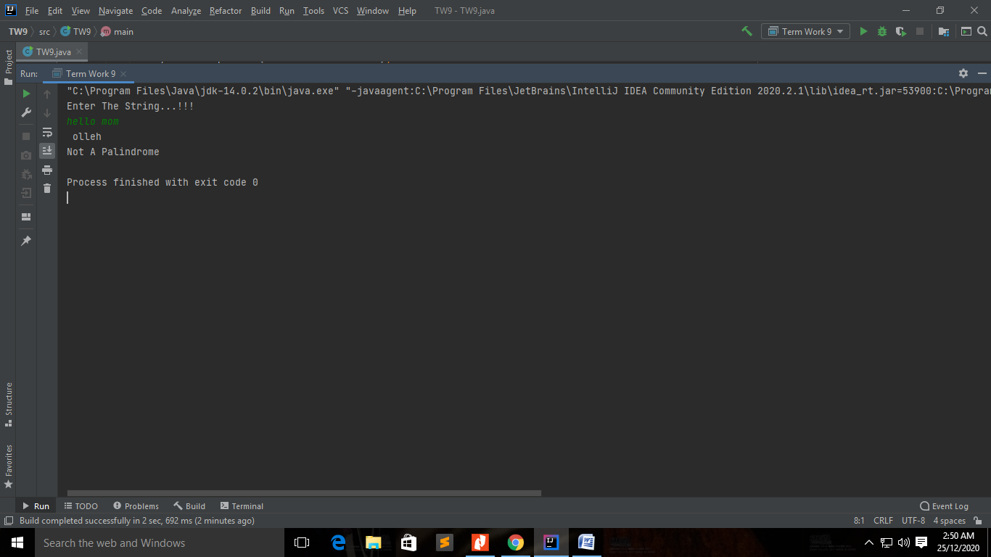

Case 2:

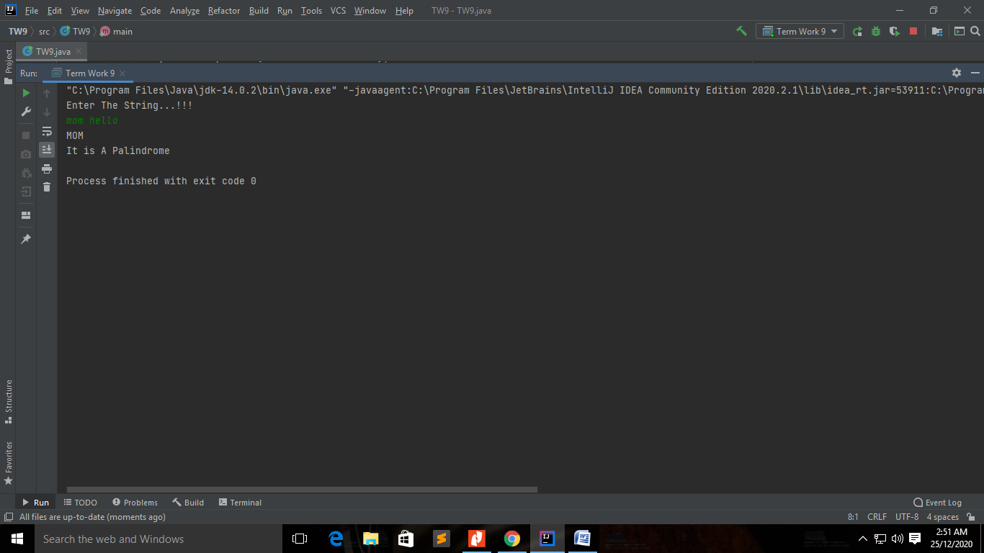

**Outcomes of the Experiment :** At the end of the laboratory sessions the students should be able to

1. Demonstrate the use of String Handling Concept.
2. Understand Java String contains an immutable sequence of Unicode characters
3. Understand string is an object that represents a sequence of characters or char values. The java.lang.String class is used to create a Java string object
4. Will Understand the Importance of String Handling Functions
5. Will understand the use of Various use of String Functions

**Conclusions :** From the given problem statement, we could identify the necessary variables of appropriate type,and looping/control statements and the necessary program logic. The program was written in IntelliJ IDE(Mention the one you actually used) by creating a project. We understood the usage of the IDE in typing the code, debugging, running the program and observing the output. We also understood the use of built-in class System and its method println to display the result. The program was executed for two-three sets of input and result obtained were verified to be correct and recorded.

Strings are a sequence of characters and are widely used in Java programming. In the Java programming language, strings are objects. The String class has over 60 methods and 13 constructors.

The String class also includes a number of utility methods, among them split (), to Lowercase (), to Uppercase (), and value Of(). The latter method is indispensable in converting user input strings to numbers. The Number subclasses also have methods for converting strings to numbers and vice versa.  
  
In addition to the String class, there is also a [String Builder Class In Java](https://java.meritcampus.com/core-java-topics/java-stringbuilder-class-or-stringbuilder-class-in-java) class. Working with [String Builder Class In Java](https://java.meritcampus.com/core-java-topics/java-stringbuilder-class-or-stringbuilder-class-in-java) objects can sometimes be more efficient than working with strings. The [String Builder Class In Java](https://java.meritcampus.com/core-java-topics/java-stringbuilder-class-or-stringbuilder-class-in-java) class offers a few methods that can be useful for strings, among them reverse (). In general, however, the String class has a wider variety of methods.  
  
A string can be converted to a string builder using a StringBuilder constructor. A string builder can be converted to a string with the [to String ()](https://java.meritcampus.com/core-java-topics/java-string-conversion-and-tostring-method-in-java) method.

**Problem Statement(Practice) :**

9.2) Two strings will be anagram to each other if and only if they contain the same number of

characters (order of the characters doesn;t matter). That is, If the two strings are anagram to

each other, then one string can be rearranged to form the other string. For Example: creative

and reactive are anagrams. Write a Java program to test whether two strings are anagrams or

not. (listen and silent, stressed and desserts, dusty and study)

**Program Source Code :**

mport java.util.Arrays;  
import java.util.Scanner;  
  
class TW9b {  
 public static void main(String[] args) {  
 String str1;  
 String str2;  
 Scanner input=new Scanner(System.*in*);  
 System.*out*.println("Enter String 1...!!!");  
 str1=input.next();  
 System.*out*.println("Enter String 2...!!!");  
 str2=input.next();  
  
 // check if length is same  
 if(str1.length() == str2.length()) {  
  
 // convert strings to char array  
 char[] charArray1 = str1.toCharArray();  
 char[] charArray2 = str2.toCharArray();  
  
 // sort the char array  
 Arrays.*sort*(charArray1);  
 Arrays.*sort*(charArray2);  
  
 // if sorted char arrays are same  
 // then the string is anagram  
 boolean result = Arrays.*equals*(charArray1, charArray2);  
  
 if(result) {  
 System.*out*.println(str1 + " and " + str2 + " are anagram.");  
 }  
 else {  
 System.*out*.println(str1 + " and " + str2 + " are not anagram.");  
 }  
 }  
 else {  
 System.*out*.println(str1 + " and " + str2 + " are not anagram.");  
 }  
 }  
}

**Output :**

**Case1**

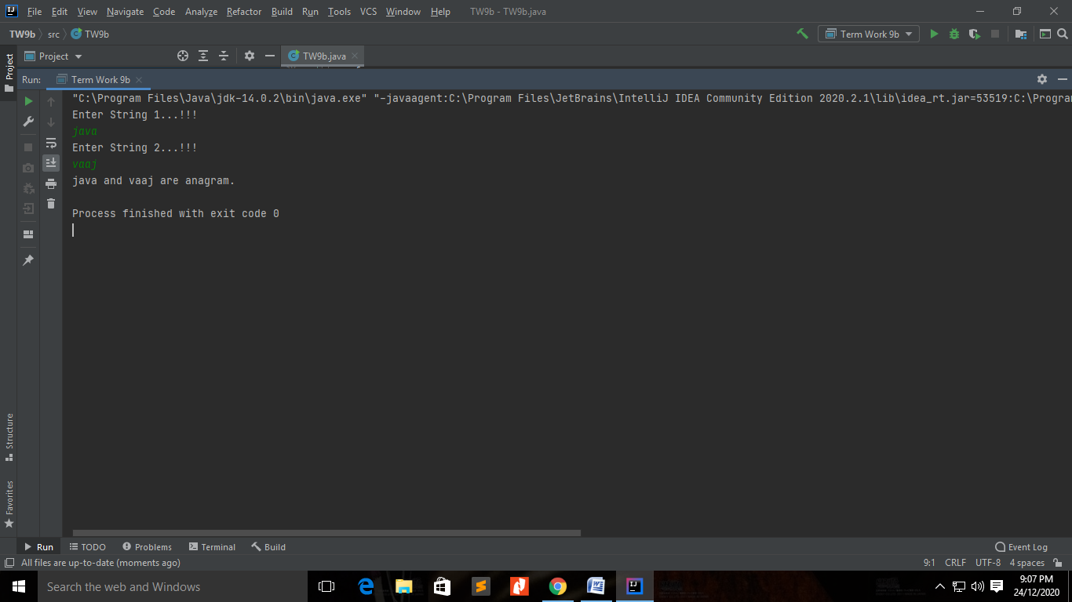

**Case 2**

